1.
Log in to your home Wi-Fi router's admin panel using its default IP address (usually 192.168.0.1 or 192.168.1.1) and take a screenshot of the login page.<br><br><em><strong>Hint:</strong> If you don't know your router's IP, open Command Prompt and run 'ipconfig' — look for 'Default Gateway'.</em>
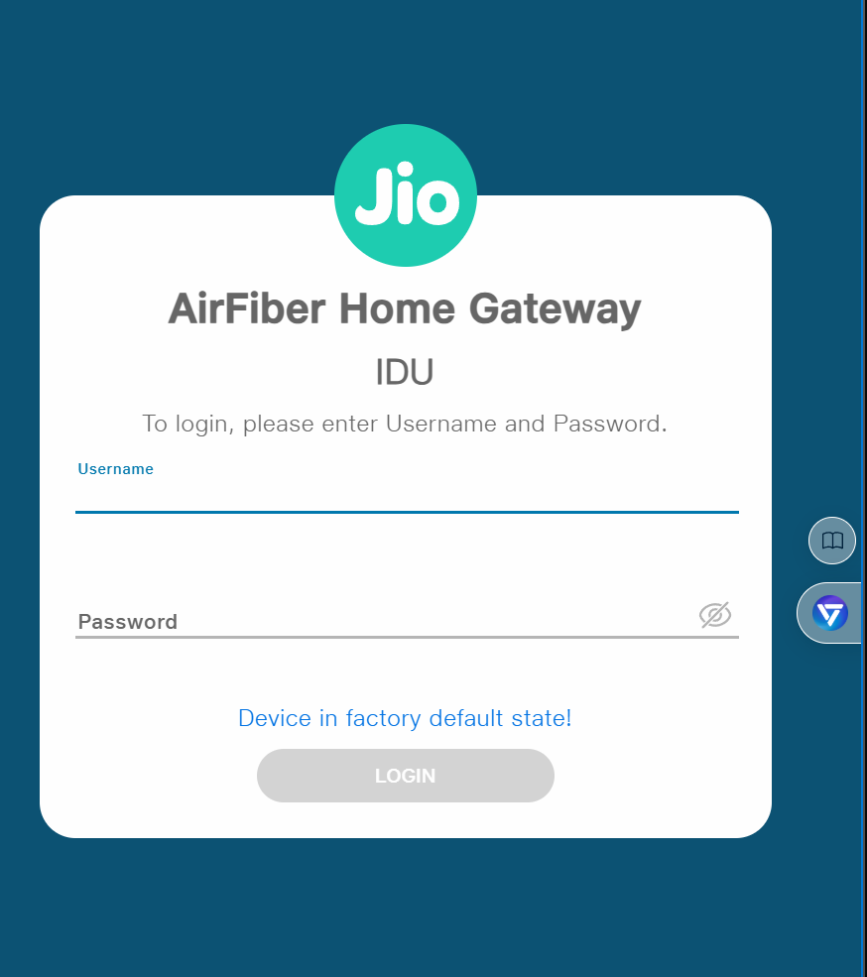

2.
Find and note down the current IP address, subnet mask, and default gateway assigned to your laptop or mobile device when connected to your Wi-Fi network.
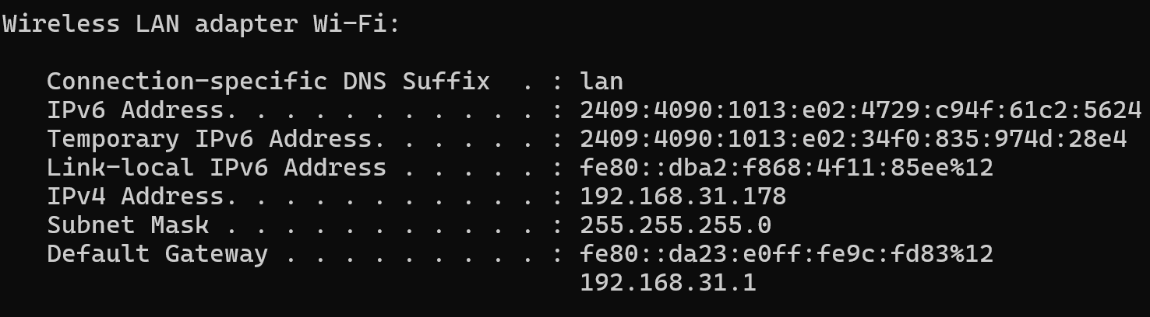
3.
Change your device's IP address from 'Obtain IP automatically' (DHCP) to a static IP in the same range as your router (for example, set it to 192.168.1.50 if your router is 192.168.1.1), and test if you still have internet access.<br><br><em><strong>Constraint:</strong> Remember to revert to automatic/DHCP after testing to avoid network issues.</em>
Go to Control Panel → Network and Sharing Center → Change adapter settings.
Right-click Wi-Fi → Properties → Internet Protocol Version 4 (TCP/IPv4).
Example:
  - IP: 192.168.1.50
  - Subnet Mask: 255.255.255.0
  - Default Gateway: 192.168.1.1
  - DNS: 8.8.8.8 (Google DNS)
Save and test internet access.
Revert back to Obtain IP automatically after testing.

4.
In your router's admin panel, locate the section where you can view or change the DHCP range. Write down the current range, and explain in 2-3 lines what would happen if two devices are assigned the same IP address in this range.
- In your router’s admin panel, look for LAN / DHCP settings.
- You’ll see something like:
  - DHCP Range: 192.168.1.2 – 192.168.1.100
- Explanation: If two devices get the same IP in this range, they will conflict.
  - Result: Both may lose connectivity, or one device will disconnect.
  - The router cannot properly route traffic because IPs must be unique.

